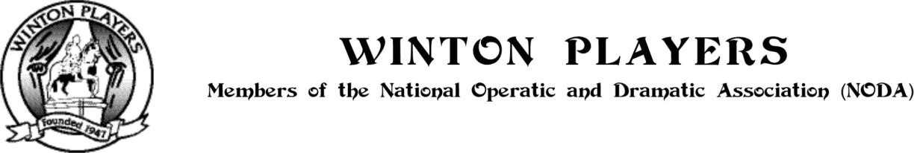
Please complete Sections 1, 2, 3 & 4 (Section 4 is optional) and then forward the form to: wintonplayerssecretary@gmail.com

Name
Address
Postcode
Telephone
Mobile
Email

Membership category: (Please mark √ or X)

Adult (£42) |  | Student (£16.00) |  | Junior (£16.00)

Student is a person in Year 12 or above who is in full time education (college/university). Junior is Year 11 and below.

TO BE COMPLETED FOR JUNIOR MEMBERS ONLY

Date of Birth
Name of Parent / Guardian
Telephone / Mobile
Email

SECTION 2 - Subscription & payment
Please delete as necessary and mark √ or X in the appropriate box
I enclose cheque / cash for subscription
I have paid by BACS transfer to the Winton Players Account: Sort code: 30-96-61, Account Number: 21850468 – please give surname & initial as reference.

GIFT AID
I have already supplied a gift aid form |  | I have completed the Gift Aid form printed overleaf |  | I cannot claim Gift Aid

SECTION 3 - I am particularly interested in: [Please mark √ or X against all that apply. Or if filling out electronically. Highlight in Bold those that apply]
Acting |  | Make-Up, Wigs & Dressing |  | Set Construction
Catering |  | Painting Scenery |  | Set Design
Chaperoning |  | Production Co-Ordinator |  | Sound
Directing |  | Properties |  | Stage Crew
Front of House Duties |  | Publicity |  | Stage Management
Front of house Management |  | Set Building |  | Wardrobe / Costumes

Registered Charity Number: 1147383

SECTION 4 - Winton Players Privacy Statement - The information supplied by a member on this form, or otherwise, is to record details of his/her membership of Winton Players (WP) and to authorize WP communications by any of the means indicated by the member. WP will securely and confidentially use and process the information ONLY in communications to the member and no information relating to a member will otherwise be processed, provided, or published outside the management, administration and approved activities of WP without the specific consent of the member.

SECTION 5 - Data Protection
- I agree that the information on this form is personal data to be retained by Winton Players (WP) as my membership record and to authorise the method(s) of communication I have indicated below.
- WP will retain the information in my membership record, and any other personal information that I may provide, electronically and in a confidential and secure manner; and will process the information only within the WP management, administration, and approved activities.
- WP will retain my membership record for the duration of my WP membership and that I will not continue to receive information circulated to members after my membership ends.
- I can request an amendment, correction or erasure of my record at any time.
- I have read and accept the WP Privacy Statement as printed above.

SECTION 6 - Consent for Communications I wish to continue to receive the Winton Players Newsletter and information about all productions, auditions, meetings, social events and all other Winton Players news and events proposed for circulation to members

Email |  | Telephone |  | Post |  | Text |  | WP Closed Group on Facebook

SECTION 7 - Gift Aid Declaration

I want the charity to treat:

- the enclosed donation of £ ............................................ as a Gift Aid donation

- the donation(s) of £ ...................................... which I made on ..../..../....... as (a) Gift Aid donation(s)

- all donations that I make from the date of this declaration until I notify you otherwise as Gift Aid donations
- delete as appropriate
You must pay an amount of Income Tax and/or Capital Gains Tax at least equal to the tax that the charity reclaims on your donations in the appropriate tax year - (currently 25p for each £1 you give).
NOTES
- You can cancel this Declaration at any time by notifying the charity.
- If in the future your circumstances change and you no longer pay tax on your income and capital gains equal to the tax that the charity reclaims, you can cancel your declaration.
- If you pay tax at the higher rate you can claim further tax relief in your Self Assessment tax return.
- If you are unsure whether your donations qualify for Gift Aid tax relief, ask the charity. Or, refer to help sheet IR65 on the HMRC web site. (www.hmrc.gov.uk)
- Please notify the charity if you change your name or address.

Signed
Date

Registered Charity Number: 1147383

